Install Nagios 4.3.2 on Ubuntu 16.04:

Prerequisites:
Nagios 4.3.2 is the latest version at the time of writing, before compiling the Nagios from the source; you need to install dependent packages for Nagios to work.
PS: Get the Latest version of Nagios from the official page.
Let’s switch to root user.
sudo su
Update the repository cache and install the dependencies for Nagios 4.
apt-get update
apt-get install build-essential apache2 php7.0 openssl perl make php7.0-gd libgd2-xpm-dev libapache2-mod-php7.0 libperl-dev libssl-dev daemon wget apache2-utils unzip
Create nagios user and nagcmd group (allowing the external commands to be executed through the web interface), add the nagios and apache user to the part of the nagcmd group.
useradd nagios
groupadd nagcmd
usermod -a -G nagcmd nagios
usermod -a -G nagcmd www-data
cd /tmp
wget https://assets.nagios.com/downloads/nagioscore/releases/nagios-4.3.2.tar.gz
tar -zxvf nagios-4.3.2.tar.gz
cd /tmp/nagios-4.3.2/

Compile and Install Nagios:
Perform below steps to compile the Nagios from the source code.
./configure --with-nagios-group=nagios --with-command-group=nagcmd --with-httpd_conf=/etc/apache2/sites-enabled/
make all
make install
make install-init
make install-config
make install-commandmode
make install-webconf

Configure Nagios:
Configuration files have now been placed by the installer in the /usr/local/nagios/etc directory. These default configuration files should work fine for now to start Nagios. All you need to make just one change before you proceed…
Edit the /usr/local/nagios/etc/objects/contacts.cfg config file and change the email address associated with the nagiosadmin contact definition to the address you’d like to use for receiving alerts.
vi /usr/local/nagios/etc/objects/contacts.cfg
Change the email address field to receive the notification.
define contact{
contact_name nagiosadmin ; Short name of user
use generic-contact ; Inherit default values from generic-contact template (defined above)
alias Nagios Admin ; Full name of user

email nagios@itzgeek.com ; <<***** CHANGE THIS TO YOUR EMAIL ADDRESS ******
}

Configure Web Interface:
Create a user account (nagiosadmin) for logging into the Nagios web interface. Remember the password you assign to this account – you’ll need it later.
htpasswd -c /usr/local/nagios/etc/htpasswd.users nagiosadmin
Run the following command.
a2enmod cgi
Restart Apache to make the new settings take effect.
service apache2 restart

Download and Install Nagios Plugins:
Now, it’s time to download Nagios plugins for monitoring the services. Place it into /tmp directory.
cd /tmp
wget https://nagios-plugins.org/download/nagios-plugins-2.2.1.tar.gz
tar -zxvf /tmp/nagios-plugins-2.2.1.tar.gz
cd /tmp/nagios-plugins-2.2.1/
Compile and install the plugins.
./configure --with-nagios-user=nagios --with-nagios-group=nagios
make
make install

Starting Nagios:
Verify the sample Nagios configuration files.
/usr/local/nagios/bin/nagios -v /usr/local/nagios/etc/nagios.cfg
Ubuntu 16.04 uses systemd for starting / stopping all the services, so, we need to create nagios.service file.
vi /etc/systemd/system/nagios.service
Add below content into above file.
[Unit]
Description=Nagios
BindTo=network.target

[Install]
WantedBy=multi-user.target

[Service]
User=nagios
Group=nagios
Type=simple
ExecStart=/usr/local/nagios/bin/nagios /usr/local/nagios/etc/nagios.cfg
Enable Nagios to start automatically at system startup.
systemctl enable /etc/systemd/system/nagios.service
Now, start Nagios service.
systemctl start nagios

Access Web Interface:
Now access the Nagios web interface using the following URL. You’ll be prompted for the username (nagiosadmin) and password you specified earlier.
http://ip-address/nagios/
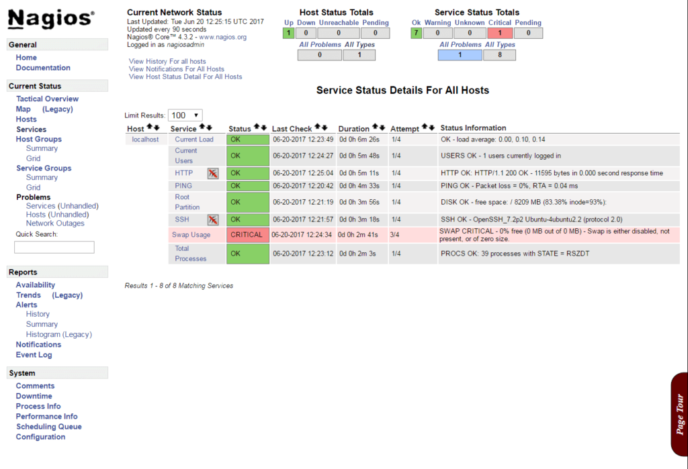

Source: http://www.itzgeek.com/how-tos/linux/ubuntu-how-tos/install-nagios-4-1-1-ubuntu-16-04.html

